**WorkersMeet.com**

Submitted by

***Yash S. Wasule1, Rishikesh N. Thakur2, Ritesh D. Thakur3, Dipak J. Yadav4, Varad S. Ashtekar5***

***Students of Vishwakarma Institute of Technology, Pune, SPPU, India***

***Abstract* —** *The current coronavirus pandemic has affected many lives around the world. In India alone, more than 10 crore people have lost their jobs and many of those people are from the construction and farming sectors as well as small business owners. Our objective is to help such people find employment according to their skillset and to make the service available to each and every one. WorkersMeet is basically a job portal but aims to provide trustworthy information that is relevant to workers. Employers can add jobs to the portal and work seekers can apply for them in a straightforward manner.*

***Keywords*** *— Django, Employer, Job, Job portal, Login Worker*

1. INTRODUCTION

Many people have lost their jobs due to the current COVID19 pandemic and have also shifted tentatively to their native place. But the Atmanirbhar Bharat scheme has presented many new job opportunities, not only in urban settings but also in small towns, villages, etc. so we are going to create a platform where workers and the seeker can communicate easily. WorkersMeet is a website for workers where they can find jobs and also for employers where they can find eligible candidates for their jobs. Workers will fill their details like type of work, experience and location. Employers can fill in the job details like duration, type of job, location and facilities provided to the workers. Based on this information, the website will show workers the available jobs based on their criteria.

1. Literature Review

Job seeking usually involves different ways to look for jobs such as through personal contacts, direct telephone calls to employers, job agency offices, etc. Before the Internet became widely used as a method of seeking jobs, jobseekers spent a lot of time using various methods to look for job openings. The traditional (old) ways for finding job opening were:

• Employment recruitment agencies

• Job fairs

• Advertising in the mass media such as newspapers

• Advertisement on television and radio

• Management Consultants

• Existing employee contacts

• Workers or professional referrals

These old job-seeking methods are too slow, stressful, challenging, and also lack quality. Also, the applicants have to consider the cost and the amount of time to get the information they need, and other preparations they have to make. The Internet is now a powerful tool that job seekers can use. Today, many sites advertise job positions to be filled by people with certain skills in various fields. The Internet plays an important role in the area of human resource planning and development. Most planning and development organizations are now using computer technology and the Internet for staff recruitment. It should be noted that although the Internet has facilitated the process of job-seeking, it has not replaced the traditional methods, completely. The use of job portals like LinkedIn is more predominant in the corporate world whereas the traditional ways are still being used in agriculture and construction. We want to simplify the task of workers and help them find a good job in their respective fields using our portal.

1. Methodology/Experimental
2. *Materials/Components/Flowchart/Block Diagram/Theory*

Components:

1. Web Portal
   1. Django [1] - Backend
   2. SQLite - Database
   3. Bootstrap [6] (HTML) - Frontend
   4. Django Templating Engine - Frontend

Block Diagram:

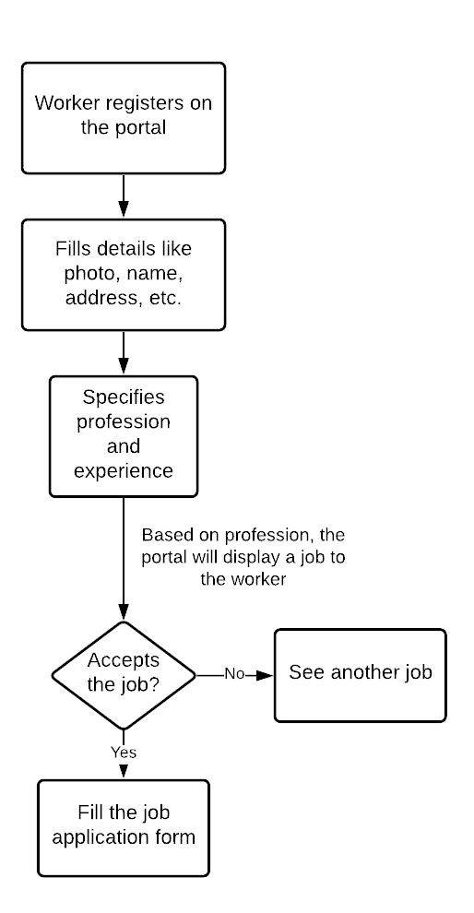

1. Use of portal by worker

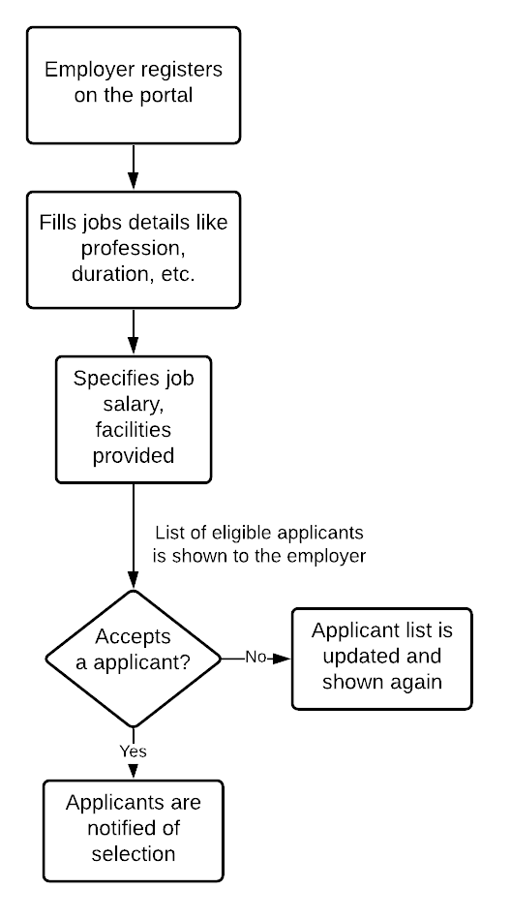

1. Use of portal by employer
2. *Synthesis/Algorithm/Design/Method*

We are creating a website where we can store workers' information and job givers' information. First workers have to do registration on our site. Job givers also have to do the registration. Then, they have to fill out a form where we are storing all workers' information regarding their skills, work experience, and their hometown. Workers can find jobs that look appropriate for them. Also, recruiters can find workers and select them according to their job requirements. Our websites will show notifications if workers get jobs.

The intention of Job Portal is to facilitate both the candidates seeking jobs as well as the employers looking for employees for their companies. In this online application, any job seeker can search for the available jobs at any moment with updated information. When he finds a job, he can post his application to the job online. Employers can post the job information with the eligibility criteria for the jobs. This software establishes a direct connection between the employer and the job seeker. A job seeker can directly visit this portal and view the jobs availability information along with downloading the required information. When he logs into the system, he would be able to upload his application and post walk-in details which he knows would be held by a company. This information helps other users very much to attend the same. Further, the user will be able to view the list of companies for which he has already applied. This enables him to make a decision when he gets a call from a company and how much time elapsed since he has applied for the company.

It provides an efficient way to pass the information between different users to cater their needs. It is a Complete Portal for Job seekers and employers. It is an exclusive career portal aimed just for the service of job seekers. It is a common platform where corporate recruiters and job seekers come under the roof. It is a one stop information clearing house about jobs and careers. Job Miller mainly aims on two kinds of users

1. **Admin** - Spring Security provides the Admin login. The Admin module provides various functionalities. The Admin users are responsible for activating and deactivating the employer accounts. In addition, Admin users can view the list of employers registered with the application.
2. **Job Seekers** - In this module Job Seeker register himself and upload his resume and fill the profile given by admin and after login he will search for the job on various conditions and he can change his profiles and resume and he can apply for the jobs based on various conditions. He can see the response of the company and he can call the company person for the interview.
3. **Employers** - Get instant access to today's most powerful hiring tools - post jobs, search resumes, screen candidates and streamline your entire hiring process. In this module Job Provider register himself and his company and after login he will add a new job and he can search for the job seekers on various conditions and he can offer the job-to-job seekers according to the job profile and he can also see the response from the job seekers and send the mail.
4. **Authentication** - This module contains all the information about the authenticated user. User without his username and password can’t enter into the login if he is only the authenticated user then he can enter his login.
5. Results and Discussions

This are the functionalities available in our site:

1. **Home Page**: The home page appears on the start of the application. The screen will provide various functionalities like Home, Admin, Employer Registration, Employer Login, Jobseeker Registration and Jobseeker Login. When clicked on the button, it navigates to the respective screens.

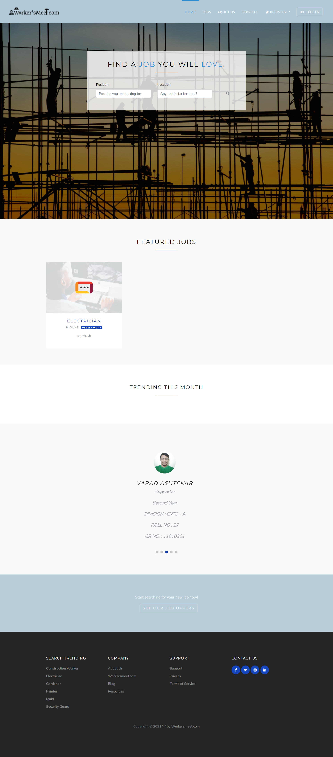

2. **Login Page**: We prepared a login page with a back-end. The Job seeker can login or sign up with the application.

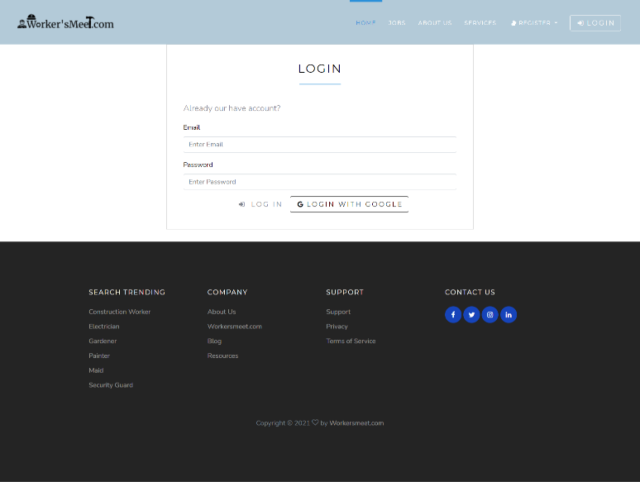

3. **Registration Page**: The Job seeker as well as recruiters can login or sign up with the application.

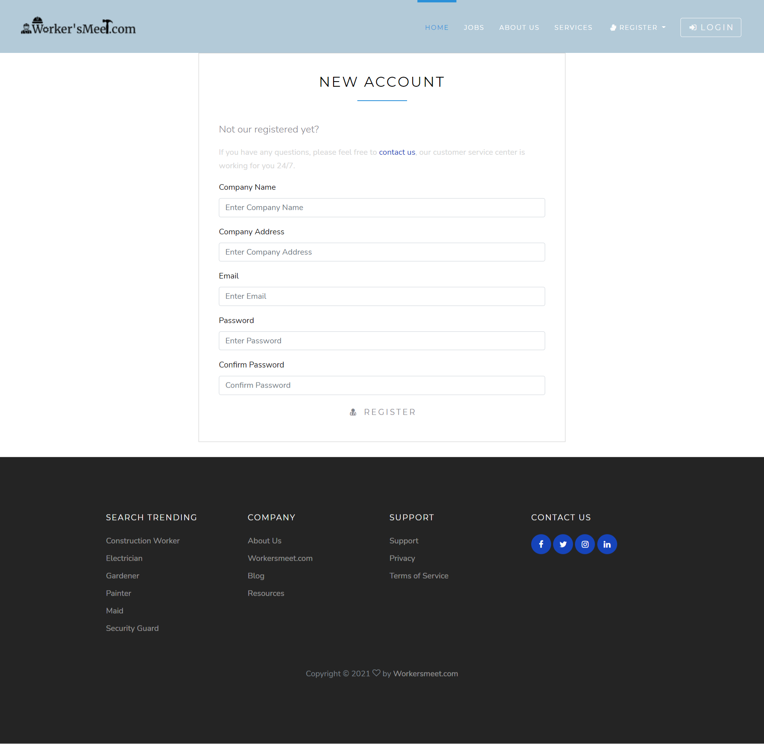

4. **Applied Jobs List Page:** The Jobs Screen provides the list of jobs applied. One can view the listed jobs and apply if interested. 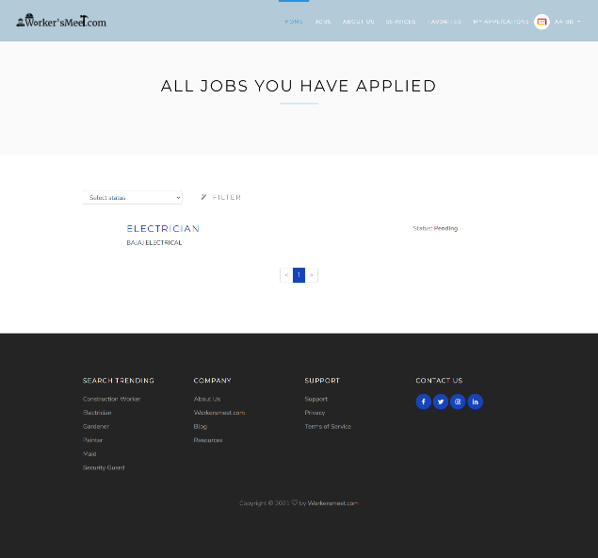

5. **Jobs Detail Page**: After choosing to view the job posting on the Jobs screen, the details of the jobs will be displayed.

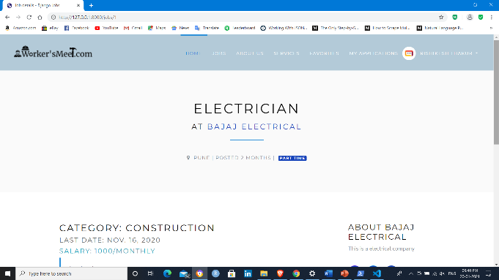

6. **Job Posting Page**: On clicking the Post New Job tab on the Employer page, the employer navigates to the Post New Job page where he posts current job opening with summary of qualifications and responsibilities.

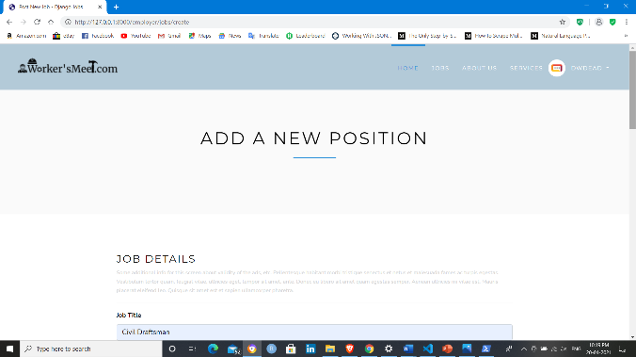

7. **Jobseeker Dashboard**: After successful registration and login, jobseeker navigates to the Job Portal Page facilitating the functionalities of viewing his/her profile, Search Jobs, view applied jobs and add reviews.

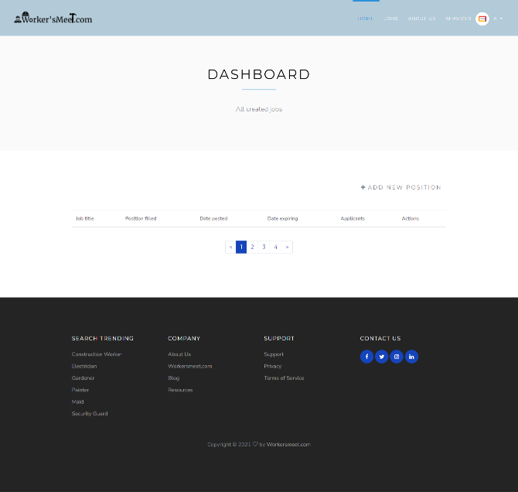

8. **About Us**: It will provide information about us.



1. Limitations

As the number of users increases, the size of the database increases. This causes increased load on the server and also requires more storage. Currently, the data is not being backed up on an external drive. This can cause issues if the data gets corrupted or lost. The workers must be educated on how to use a computer as they might not have any prior experience. The server can handle moderate traffic but has not been tested completely, so performance might be a limitation.

1. Future Scope

We will make our platform more stable, secure and reliable. We’ll remove any bugs we encounter in the future. This project fulfils the primary requirements of the workers and employers. Hosting the application on sites like Heroku, AWS, etc. will be our major goal. But new features can be added along the way like better recommendations and email updates for new job postings based on the job seeker’s search history. Email and SMS communication to the user can also be implemented.

1. Conclusion

Job Search Portals stands as a revolutionizing element in the sphere of recruitment. They act as a communication bridge between applicants and recruiters facilitating their requirements. This application helps organizations to have a greater exposure to the candidate pool and also job seekers facilitating wide search of jobs matching their interests. It provides a user-friendly interface which facilitates in reaching a wide range of audience. Here, we designed a project “Online Job Portal system" and all its application codes are in Python with the HTML and SQLite3 backend.

It’s a web-enabled project.  This project offers users to enter the data through simple and interactive forms. This is very helpful for the client to enter the desired information through so much simplicity.

References

1. Django - “The Web Framework for perfectionists” <https://www.djangoproject.com/>
2. W3Schools - “Online Web Tutorials” <https://www.w3schools.com/>
3. YouTube - <https://www.youtube.com/>
4. CodeWithHarry - “Python Django Tutorials In Hindi” <https://codewithharry.com/videos/python-django-tutorials-hindi-0>
5. Django - “Django documentation”   <https://docs.djangoproject.com/en/3.1/>
6. Bootstrap - “The most popular HTML, …” <https://getbootstrap.com/>